**Database and file Management Systems** (CIS 2109)

**How to Connect to Oracle DB**

Follow the instructions on the following video to create a new connection:

<https://www.youtube.com/watch?v=pCEiYMkZTr0>

Before you connect you will need the following information:

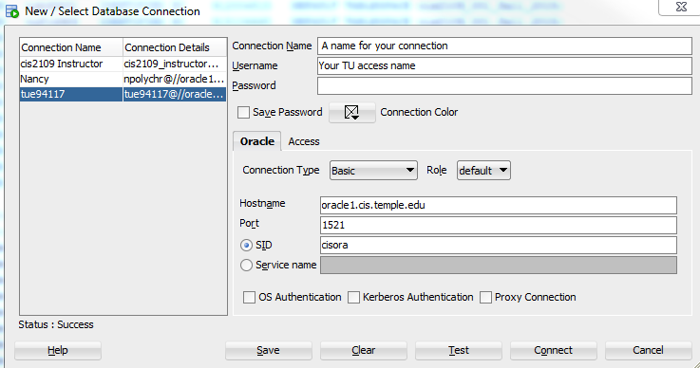

For each student the **password** is the Temple Id.